Project 3.2 - Resource Management and Horizontal Pod Autoscaling in Kubernetes

Task 1 - Deploy an Application
Deploy a containerized application inside the Kubernetes cluster using a Deployment resource.
The application will be used to simulate load and observe scaling behavior.

#vi hpa-deployment.yaml
#vi hpa-deployment.yaml
#kubectl apply -f hpa-deployment.yaml
#kubectl get deployment hpa-web-app
#kubectl get pods -l app=hpa-web-app

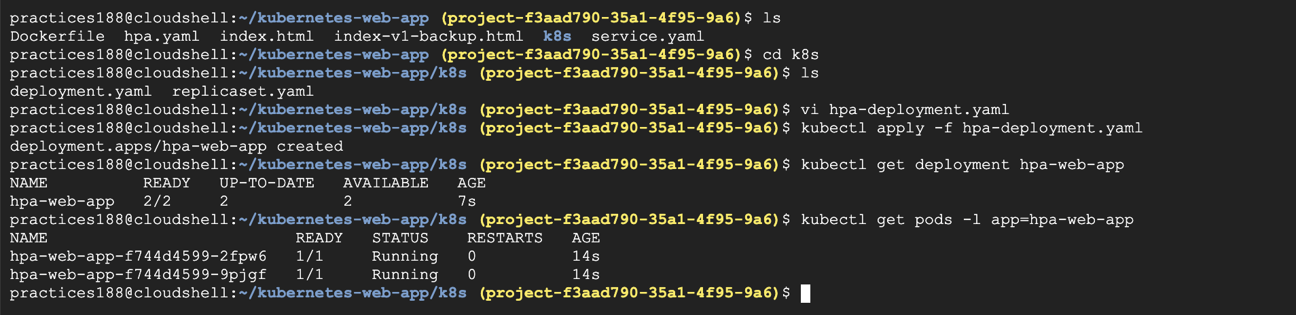

Task 2 - Define Resource Requests and Limits
Configure CPU and memory requests and limits for the containers.
These values help Kubernetes schedule workloads efficiently and prevent resource overconsumption.
We've already configured:

resources:
requests:
cpu: "100m"
memory: "64Mi"

limits:
cpu: "500m"
memory: "128Mi"

Task 3 - Verify Resource Allocation
Check that the deployed Pods are running with the configured resource settings.
Observe how Kubernetes schedules the Pods on worker nodes based on resource availability.

#kubectl get pods -l app=hpa-web-app
#kubectl get pods -l app=hpa-web-app -o name
#kubectl describe pod <POD_NAME>
Look for:
Requests:
cpu: 100m
memory: 64Mi

Limits:
cpu: 500m
memory: 128Mi

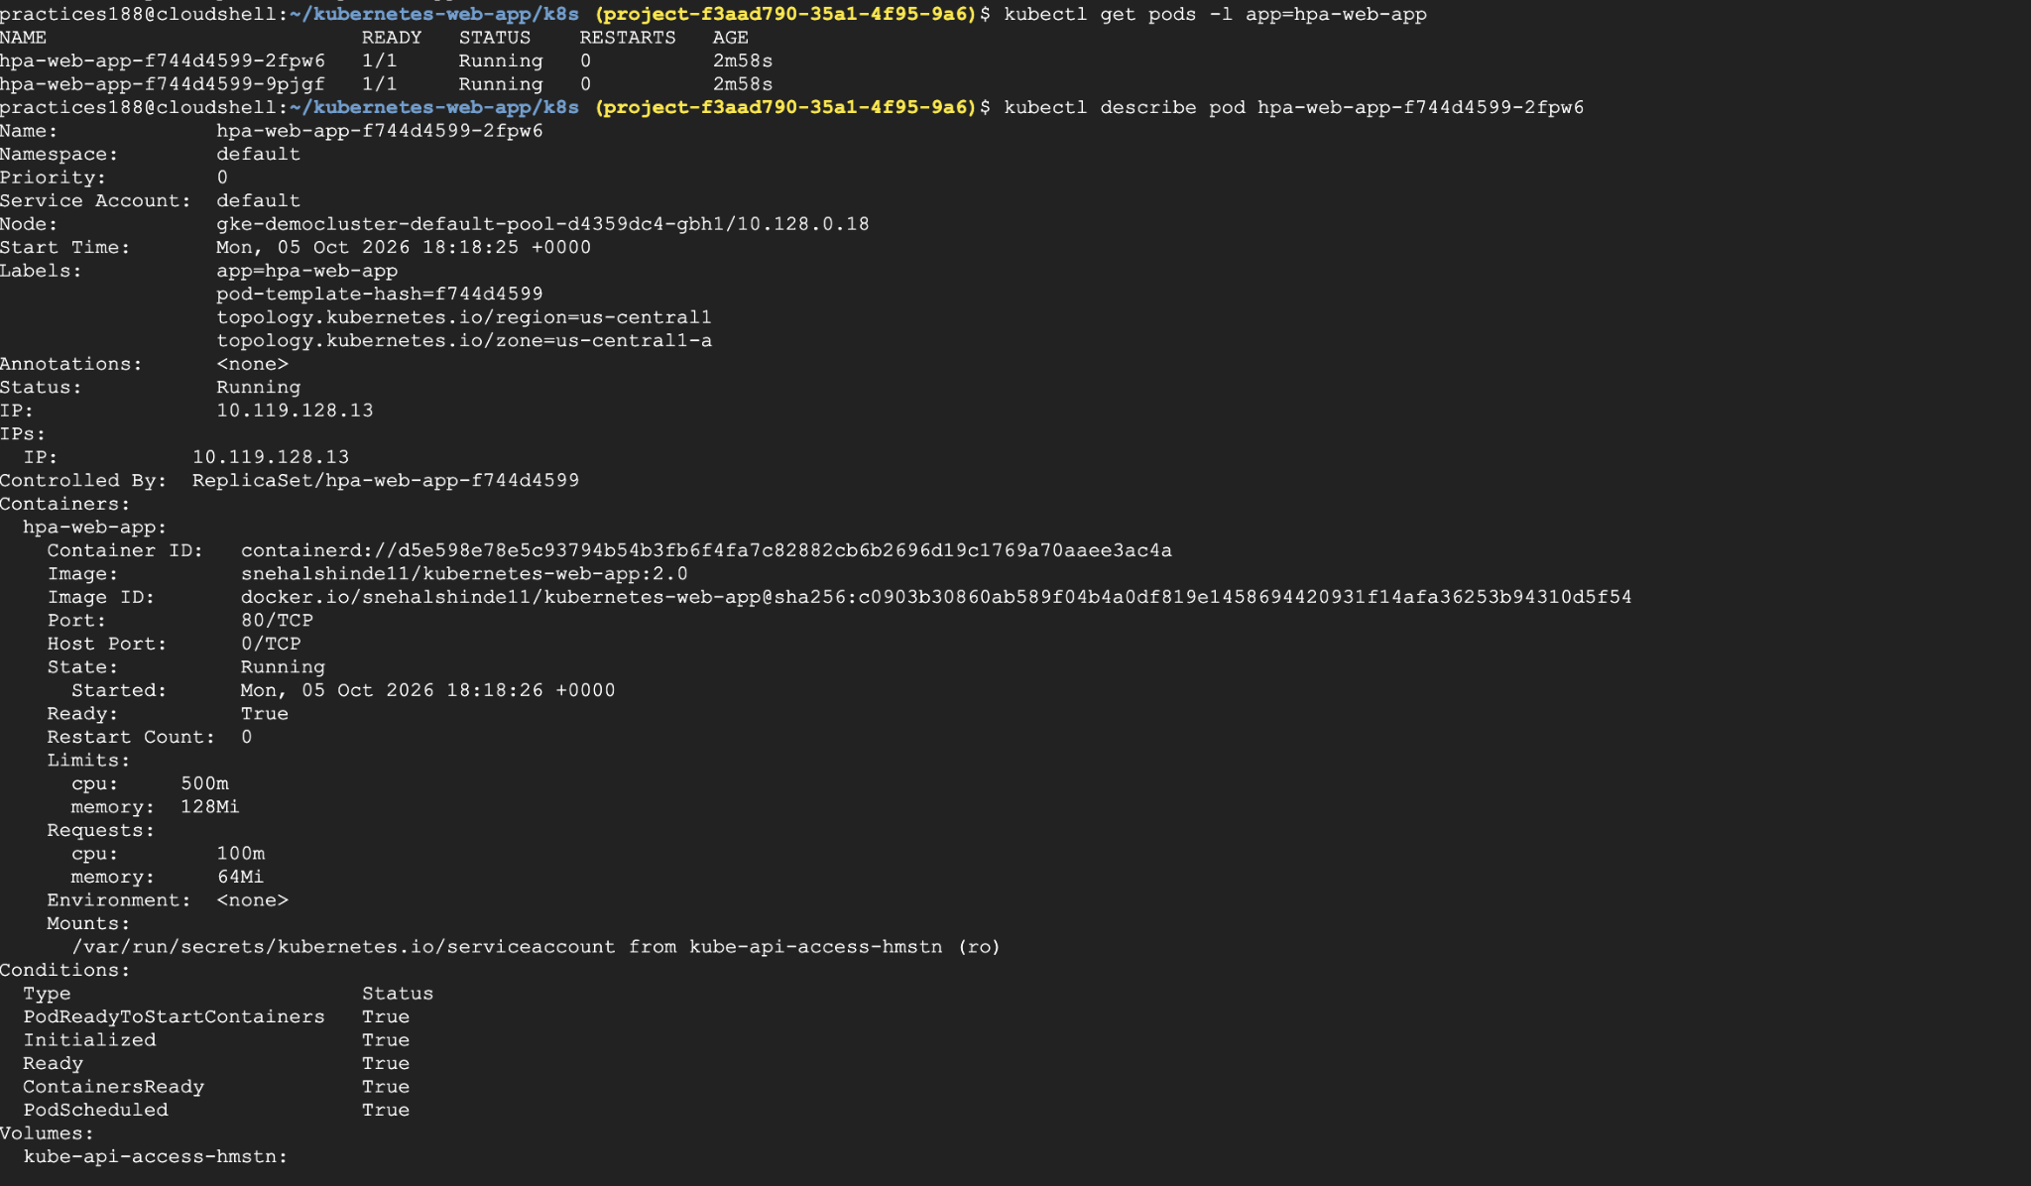

Task 4 - Configure Horizontal Pod Autoscaler
Create a Horizontal Pod Autoscaler that monitors resource usage of the deployed application.
The autoscaler should increase or decrease the number of Pods depending on resource consumption.

Before creating HPA, make sure Metrics Server is working.
If you get CPU/memory values, continue.
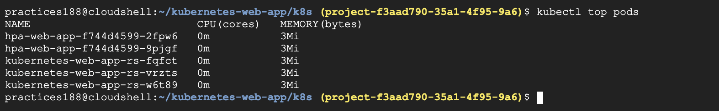
#vi hpa2.yaml
#kubectl apply -f hpa2.yaml
#kubectl get hpa

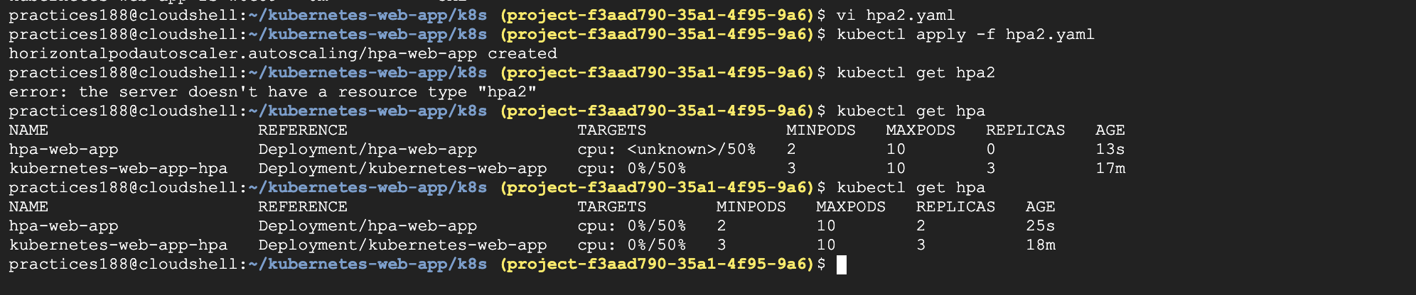

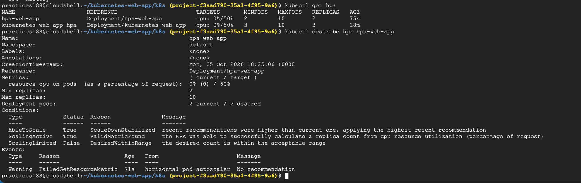

Task 5 - Simulate Application Load
Generate traffic to the application to simulate increased workload.
This will trigger the autoscaling mechanism.
We need to generate enough CPU workload to make HPA scale.
A normal HTTP request against NGINX may not generate enough CPU to trigger your HPA.
So we'll create a temporary load-generator Pod.
Create: #kubectl run load-generator \ --image=busybox:1.36 \ --restart=Never \ -- /bin/sh -c "while true; do wget -q -O- http://hpa-web-app; done"

But first we need a Service for the Deployment.
#vi hpa-service.yaml
#kubectl apply -f hpa-service.yaml
#kubectl get service hpa-web-app
Now start the load generator:
#kubectl run load-generator \
--image=busybox:1.36 \
--restart=Never \
-- /bin/sh -c "while true; do wget -q -O- http://hpa-web-app; done"
kubectl get pod load-generator
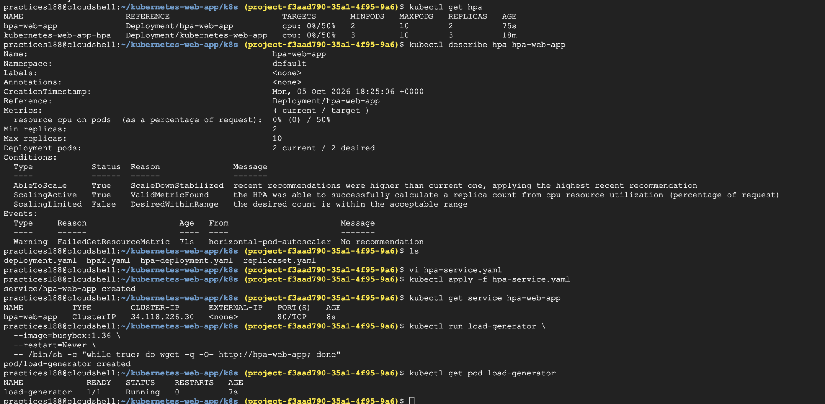

Task 6 - Monitor Scaling Behavior
Observe how the number of Pods changes as resource usage increases and decreases.
Verify that the autoscaler responds correctly to application load.

open three terminals in Cloud Shell.

Terminal 1 — HPA
#kubectl get hpa hpa-web-app -w
You'll initially see something like:
NAME REFERENCE TARGETS MINPODS MAXPODS REPLICAS
hpa-web-app Deployment/hpa-web-app 5%/50% 2 10 2
After load increases, you may see:
hpa-web-app Deployment/hpa-web-app 75%/50% 2 10 4
Then potentially:
hpa-web-app Deployment/hpa-web-app 90%/50% 2 10 8
The exact numbers and replica count depend on your cluster.
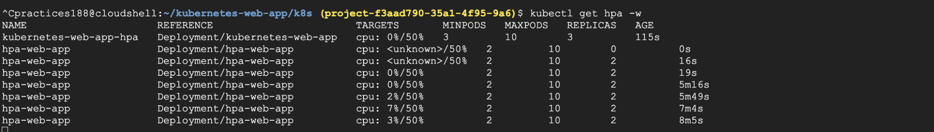

Terminal 2 — Pods
kubectl get pods -l app=hpa-web-app -w
You'll see new Pods being created:
hpa-web-app-xxxxx 1/1 Running
hpa-web-app-yyyyy 1/1 Running
hpa-web-app-zzzzz 0/1 Pending
...
Eventually:
hpa-web-app-xxxxx 1/1 Running
hpa-web-app-yyyyy 1/1 Running
hpa-web-app-zzzzz 1/1 Running

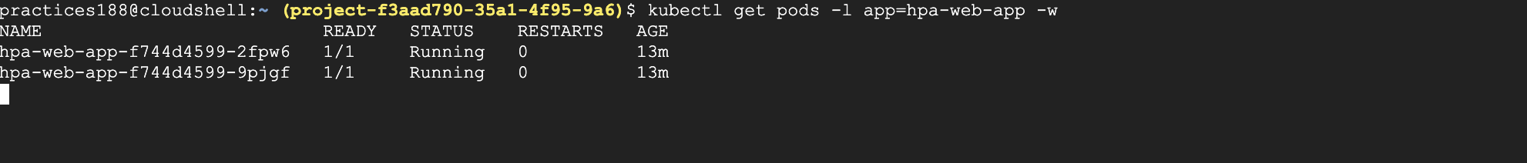
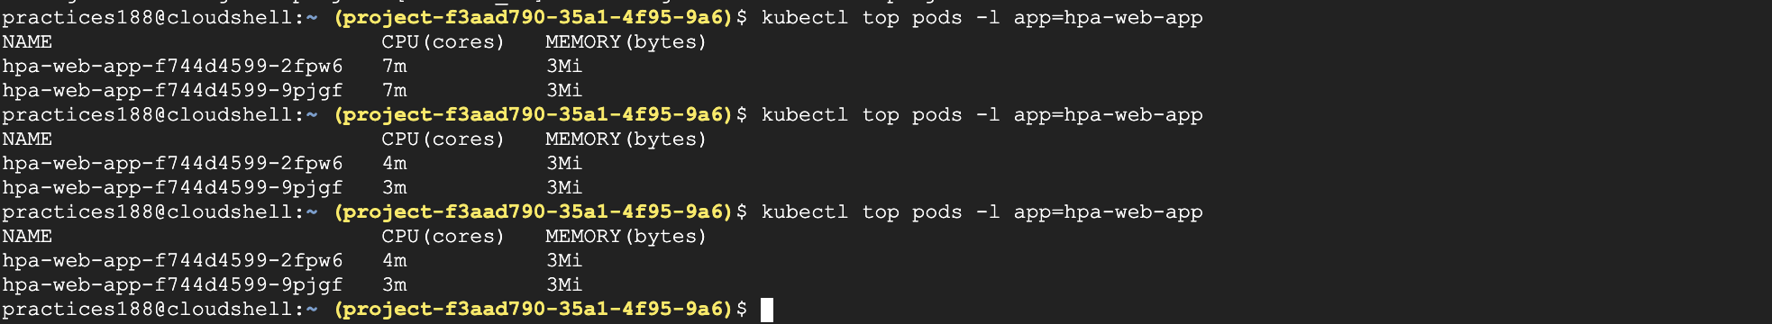

#Stop the load generator : kubectl delete pod load-generator

